**Answer1:** Class name is “Person”

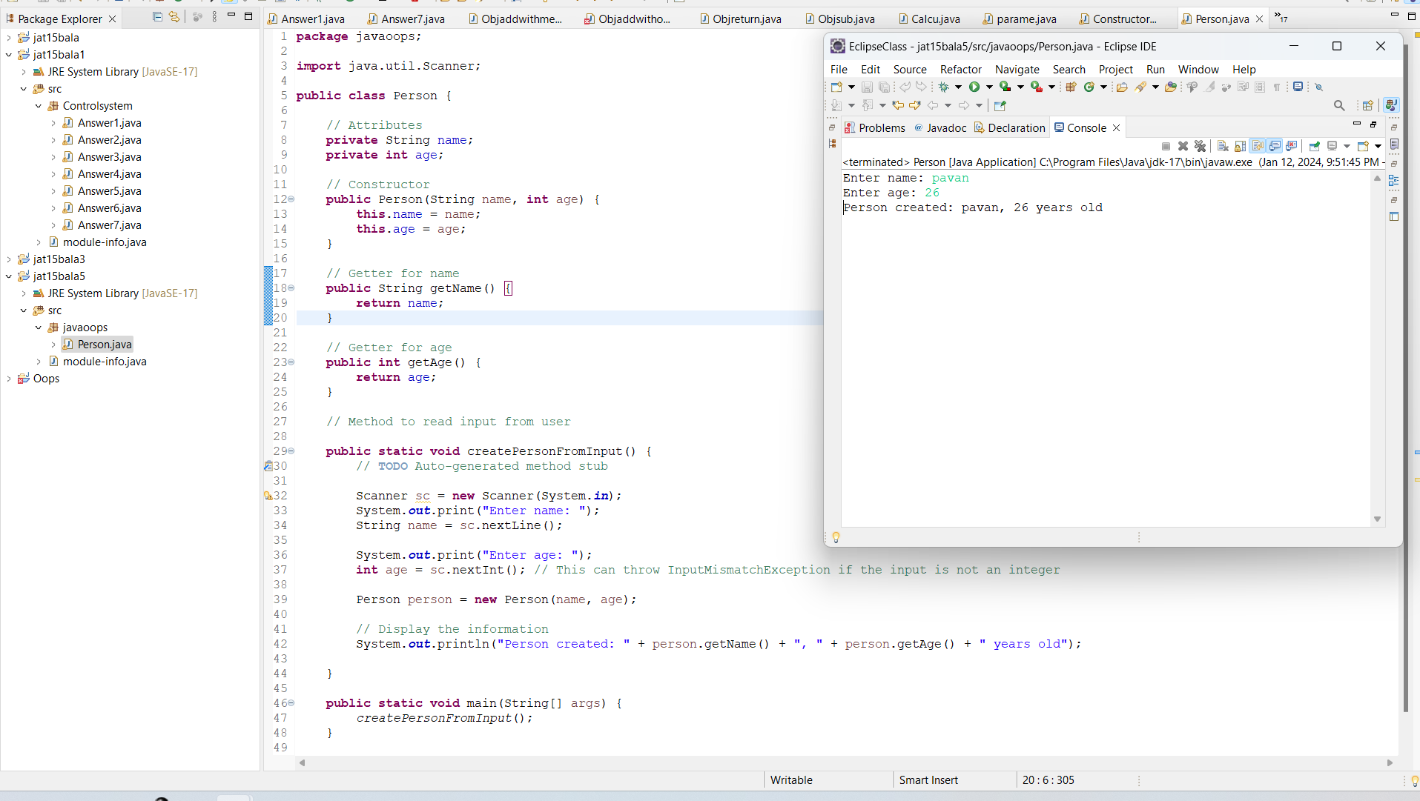

**Answer2:** Class name is “Employee”

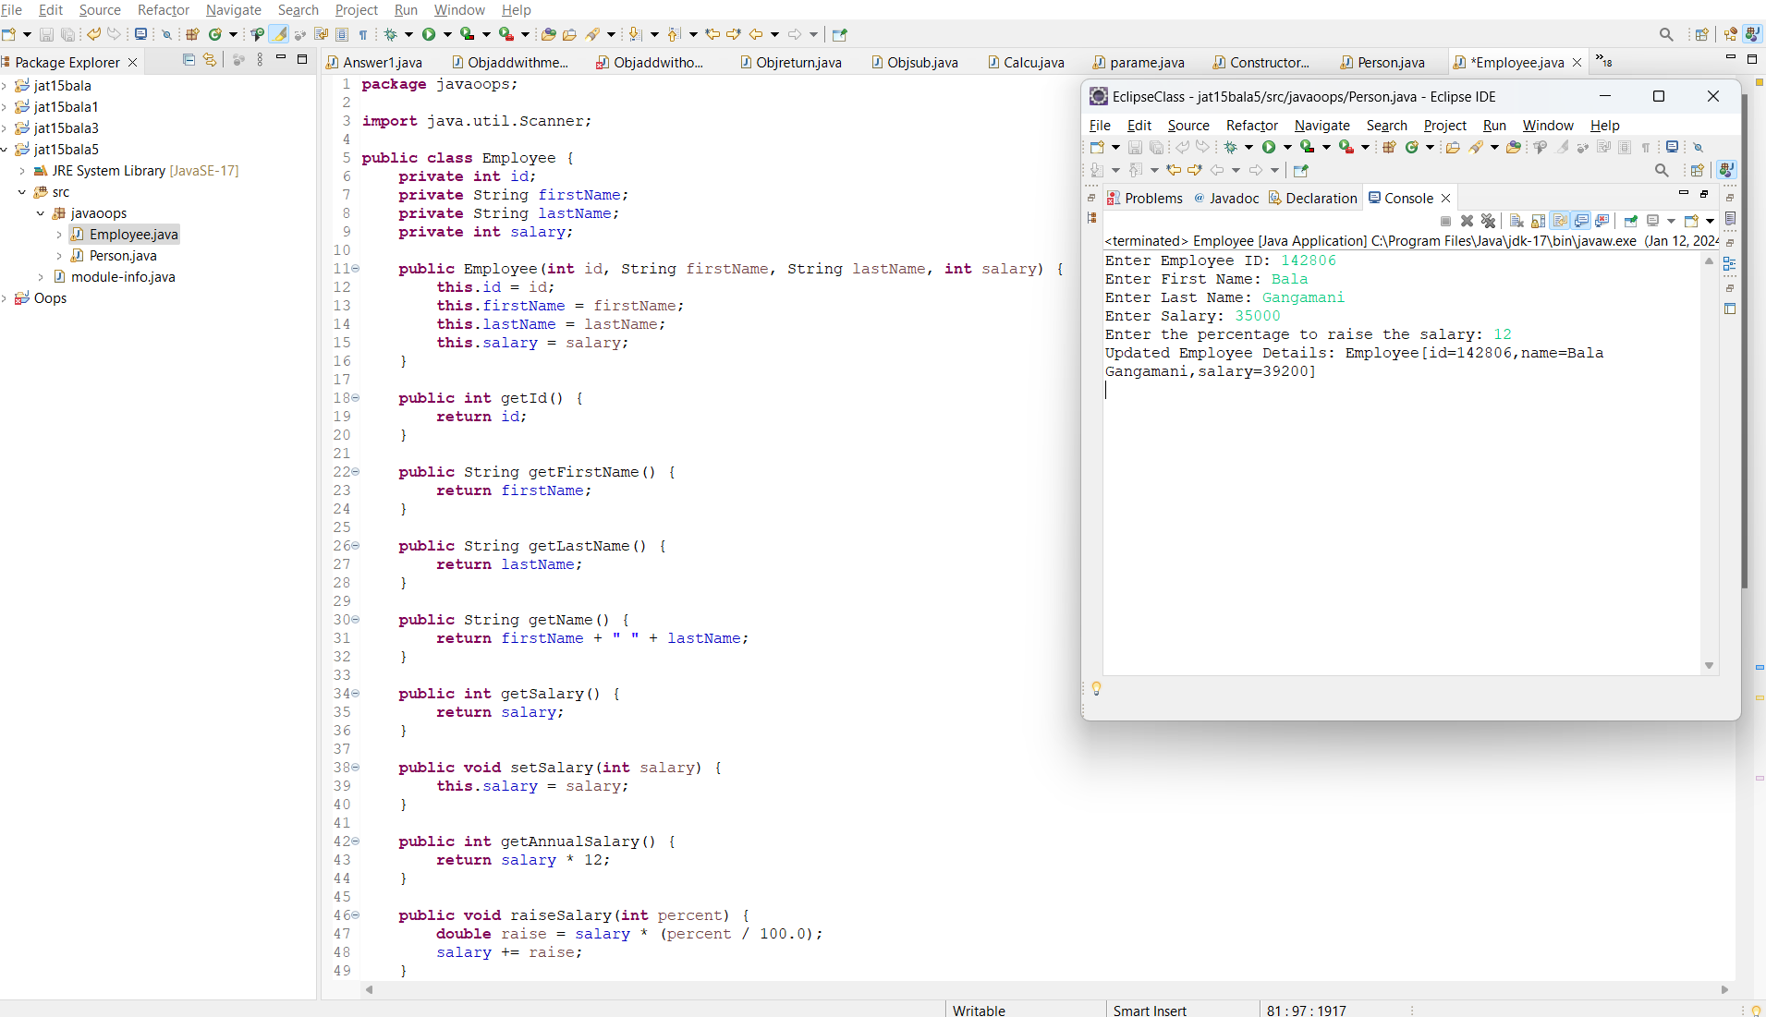

**Answer3:** Class name is “Circle”

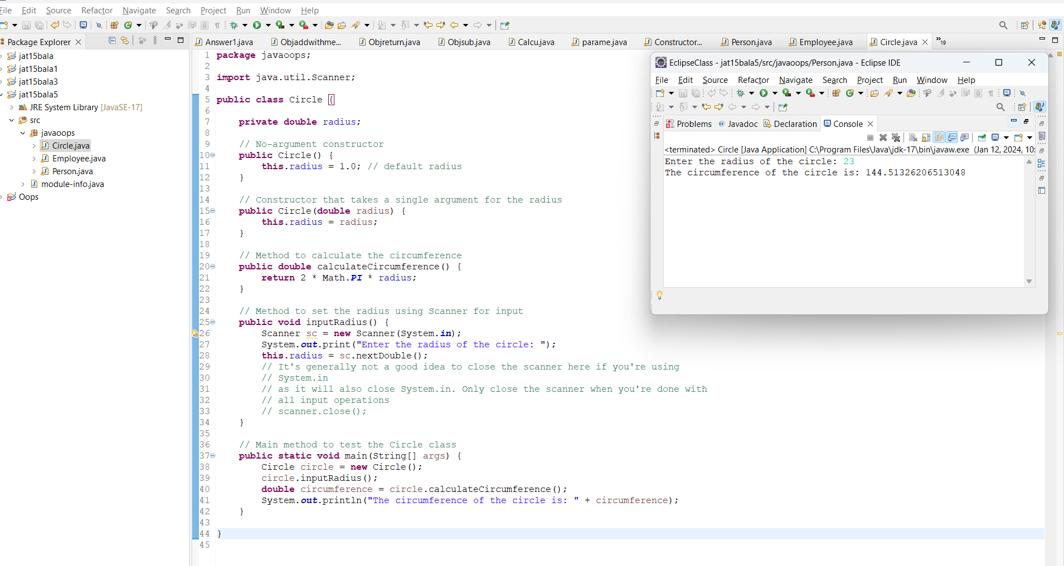

**Answer4:** Class name is “Account”

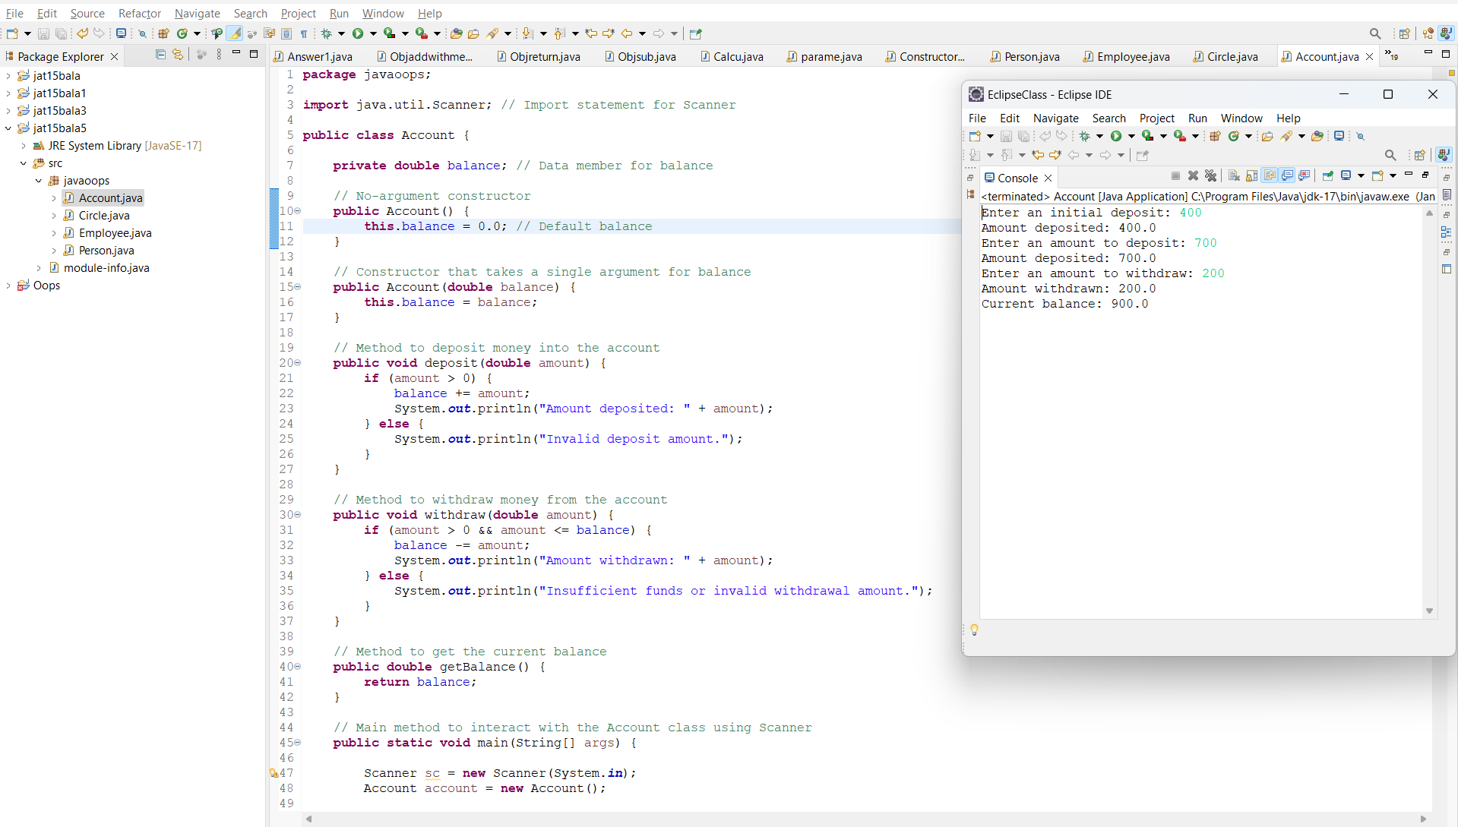

**Answer5:** Account name is “Tea”

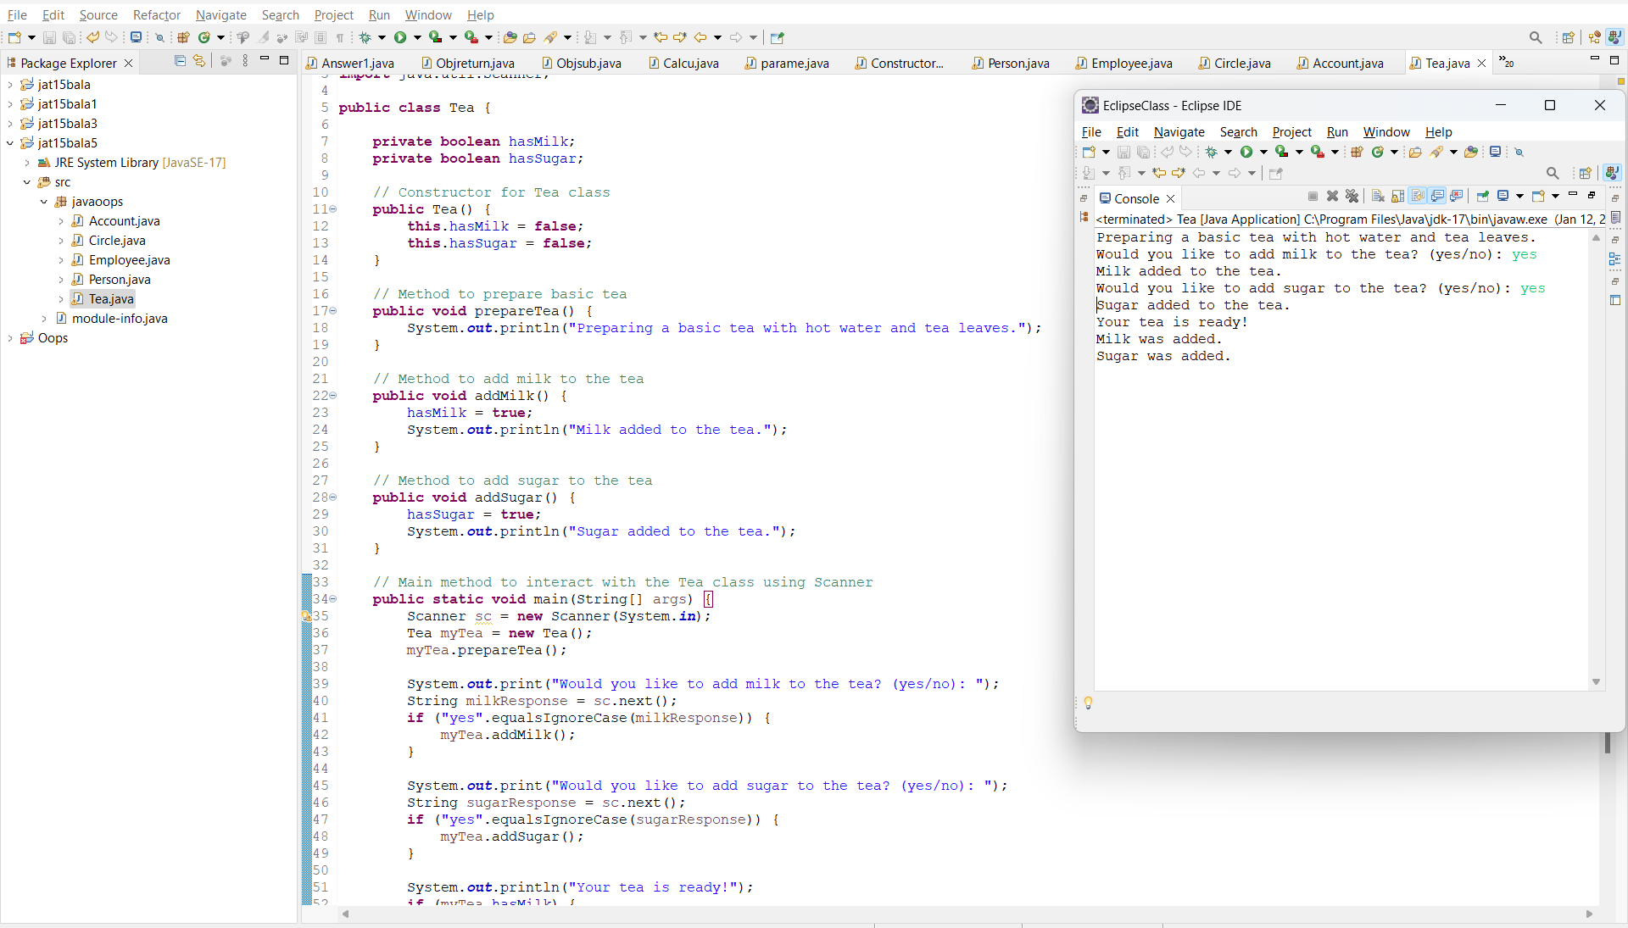

**Answer6:** Class name is “TeaShop”

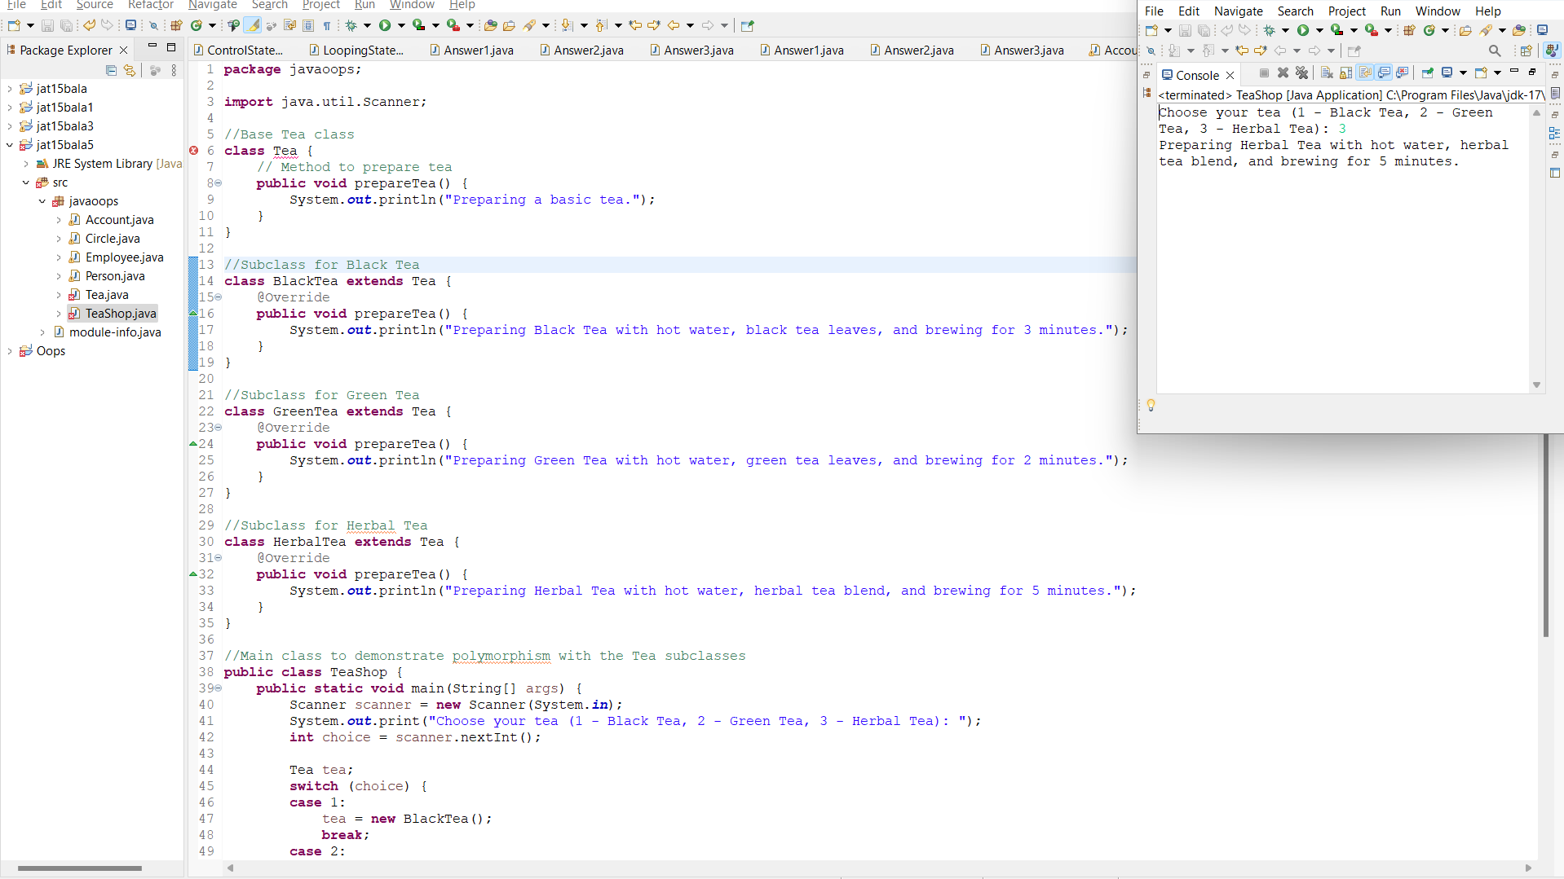

**Answer7:** Class name is “Main”

